The United Benefice of Barlborough and Clowne
St John the Baptist, Clowne
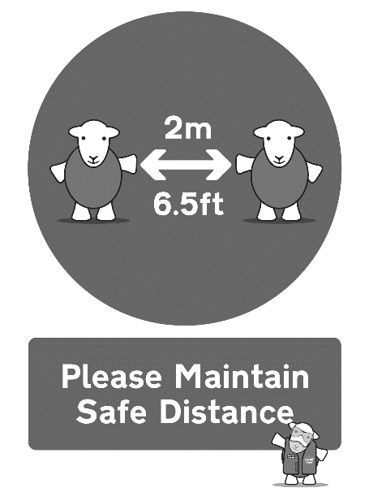
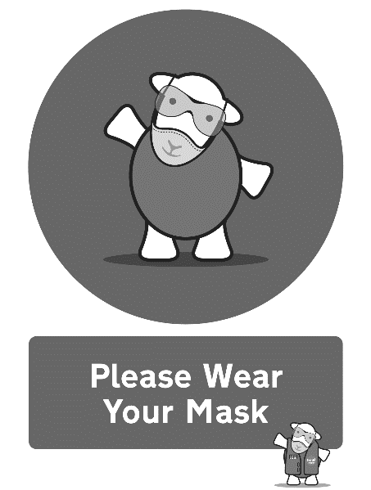
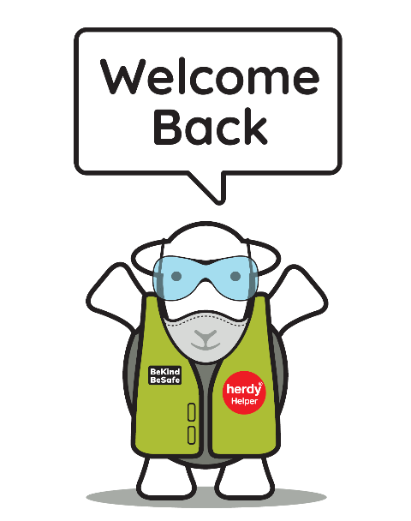

Eucharist for the Second Sunday of Advent
Sunday 5th December 2021

Please take this order of service home with you

Notices
Huge thanks to all who ran and supported our Christmas Fair, we made an incredible £800 for church which is amazing given that it snowed! Praise God!

Our Light of Life Christmas Memorial Services are on the following dates:

Sunday 12th December 5.00pm St James, Barlborough
Tuesday 14th December 7.00pm St John the Baptist, Clowne

As part of the Light of Life service we invite you to dedicate a light on our Christmas tree to those special people in your thoughts.

This is a special way to remember and give thanks. For each dedication you make we will give or send to you a special “Light of Life” card for you to keep or send to a friend. Please use the forms available at the back of church to make your dedication.

Please take some raffle tickets to sell to friends and family.

Christmas Appeal 2021 – supporting the Freedom Project

For this year’s Christmas appeal we are supporting the Freedom Project with their work with families and the homeless. Please bring along to church a toy up to the value of £5 or toiletries/warm socks/gloves up to the value of £5. Please leave these unwrapped so that the project workers can allocate them to the right recipients (they know the families well). You might find it easiest to put them in a gift bag, but it is fine if they are loose – they will be wrapped by staff at the Freedom Project. Place these gifts in front of the altar at church, you can bring them any time up until the Carol Services on 19th December at Barlborough and 21st December at Clowne.

Please leave any collection money on the plate provided at the back of church or even better, set up a direct debit by ringing this number in the week: 0333 002 1271. You will need your bank details and the correct code for the church you wish to give to regularly.
Parish Giving Scheme codes:
St John the Baptist, Clowne: 120612060
St James the Greater, Barlborough: 120612054

Contact the clergy:

Rev’d Bryony Taylor, Rector
01246 813569
revbryonytaylor@gmail.com

Rev’d Mike Fitzsimmons, Assistant Curate
07385 292902
rev.mike.fitz@gmail.com

Please note that the clergy’s usual day off is a Friday. Find out other information about our churches on our website: http://bcjj.org.uk

These are our upcoming service and event times for your diary:
Sunday 12th December – Third Sunday of Advent

8.30am Morning Prayer, Clowne
10.00am Benefice Eucharist, Barlborough
5pm – Light of Life Christmas Memorial Service at Barlborough – dedicate a light on our Christmas Tree

Tuesday 14th December - 7pm Light of Life Christmas Memorial Service at Clowne - Dedicate a light on our Christmas Tree

Sunday 19th December – Fourth Sunday of Advent

8.30am Morning Prayer, Barlborough
10.00am Benefice Eucharist, Clowne
5.00pm Traditional 9 Lessons and Carols at Barlborough

Tuesday 21st December - 7pm 9 Lessons and Carols at Clowne

Christmas Eve
4pm Family Crib and Carol Service at Clowne
6pm Family Crib and Carol Service at Barlborough
11.30pm Midnight Mass at Barlborough and Clowne

Christmas Day - 9.15am Festival Eucharist at Clowne
Sunday 26th December - 9.15am Said Eucharist for St Stephen in the Lady Chapel
OPENING HYMN

Please stand as you are able

42 O come o come Emmanuel

Please be seated
THE GREETING
In the name of the Father,
and of the Son,
and of the Holy Spirit. Amen.
Grace, mercy and peace
from God our Father
and the Lord Jesus Christ
be with you and also with you.

LIGHTING THE ADVENT WREATH

People of God: be glad!
Your God delights in you,
giving you joy for sadness
and turning the dark to light.
Be strong in hope therefore;
for your God comes to save.
You are God’s children.
Lord, make us one in the love of Christ
today and for ever.
Amen.

Please be seated
WE CONFESS OUR SINS
When the Lord comes, he will bring to light the things now hidden in darkness,
and will disclose the purposes of the heart. Therefore in the light of Christ let us confess our sins.

Lord Jesus, you came to gather the nations into the peace of your kingdom:
Lord, have mercy.
Lord, have mercy.

You come in word and sacrament
to strengthen us in holiness:
Christ, have mercy.
Christ, have mercy.

You will come in glory
with salvation for your people:
Lord, have mercy.
Lord, have mercy.

May the God of love and power
forgive you and free you from your sins,
heal and strengthen you by his Spirit,
and raise you to new life in Christ our Lord.
Amen.

THE GLORIA
Please stand as we sing the Gloria
Glory to God in the highest,
and peace to his people on earth.
Lord God, heavenly King,
almighty God and Father,
we worship you, we give you thanks,
we praise you for your glory.
Lord Jesus Christ, only Son of the Father,
Lord God, Lamb of God,
you take away the sin of the world:
have mercy on us;
you are seated at the right hand of the Father:
receive our prayer.
For you alone are the Holy One,
you alone are the Lord,
you alone are the Most High, Jesus Christ,
with the Holy Spirit,
in the glory of God the Father.
Amen.

THE COLLECT
The president introduces a period of silent prayer.
As we stand, let us pray.
Almighty God,
purify our hearts and minds,
that when your Son Jesus Christ comes again
as judge and saviour
we may be ready to receive him,
who is our Lord and our God. Amen.
Please sit
BIBLE READINGS
Malachi 3.1–4
See, I am sending my messenger to prepare the way before me, and the Lord whom you seek will suddenly come to his temple. The messenger of the covenant in whom you delight—indeed, he is coming, says the Lord of hosts. ²But who can endure the day of his coming, and who can stand when he appears?
For he is like a refiner’s fire and like fullers’ soap; ³he will sit as a refiner and purifier of silver, and he will purify the descendants of Levi and refine them like gold and silver, until they present offerings to the Lord in righteousness.⁴Then the offering of Judah and Jerusalem will be pleasing to the Lord as in the days of old and as in former years.
This is the word of the Lord. Thanks be to God.
Philippians 1.3–11
I thank my God every time I remember you, ⁴constantly praying with joy in every one of my prayers for all of you, ⁵because of your sharing in the gospel from the first day until now. ⁶I am confident of this, that the one who began a good work among you will bring it to completion by the day of Jesus Christ. ⁷It is right for me to think this way about all of you, because you hold me in your heart, for all of you share in God’s grace with me, both in my imprisonment and in the defence and confirmation of the gospel. ⁸For God is my witness, how I long for all of you with the compassion of Christ Jesus. ⁹And this is my prayer, that your love may overflow more and more with knowledge and full insight ¹⁰to help you to determine what is best, so that on the day of Christ you may be pure and blameless, ¹¹having produced the harvest of righteousness that comes through Jesus Christ for the glory and praise of God.
This is the word of the Lord. Thanks be to God.

GRADUAL HYMN Please stand as you are able
30 Come thou long expected Jesus
GOSPEL READING
Please remain standing and face the deacon as he reads the Gospel
Alleluia, alleluia.
Prepare the way of the Lord, make his paths straight,
and all flesh shall see the salvation of God.
cf Isaiah 40.3–5
Alleluia.

The Lord be with you
and also with you.
Hear the Gospel of our Lord Jesus Christ according to Luke.
Glory to you, O Lord.

Luke 3.1–6
In the fifteenth year of the reign of Emperor Tiberius, when Pontius Pilate was governor of Judea, and Herod was ruler of Galilee, and his brother Philip ruler of the region of Ituraea and Trachonitis, and Lysanias ruler of Abilene, ²during the high-priesthood of Annas and Caiaphas, the word of God came to John son of Zechariah in the wilderness. ³He went into all the region around the Jordan, proclaiming a baptism of repentance for the forgiveness of sins, ⁴as it is written in the book of the words of the prophet Isaiah,
‘The voice of one crying out in the wilderness:
“Prepare the way of the Lord,
make his paths straight.
⁵ Every valley shall be filled,
and every mountain and hill shall be made low,
and the crooked shall be made straight,
and the rough ways made smooth;
⁶ and all flesh shall see the salvation of God.” ’
This is the Gospel of the Lord. Praise to you, O Christ.
Please sit for THE SERMON

“Your hope is not a mocking dream; God creates in human hearts a huge desire and a sense of need, because he wants to fill them with the gift of himself…All your love, your stretching out, your hope, your thirst, God is creating in you so that he may fill you. He longs through your heart. Your insufficiency and your forgetting to long for him are no barrier. In your prayer God is seeking you and himself creating the prayer; he is on the inside of the longing.”
– Maria Boulding ‘The Coming of God’

THE APOSTLES’ CREED
Please stand as you are able

Do you believe and trust in God the Father?
I believe in God, the Father almighty, creator of heaven and earth.
Do you believe and trust in his Son Jesus Christ?
I believe in Jesus Christ, his only Son, our Lord, who was conceived by the Holy Spirit, born of the Virgin Mary, suffered under Pontius Pilate, was crucified, died, and was buried; he descended to the dead. On the third day he rose again; he ascended into heaven, he is seated at the right hand of the Father, and he will come to judge the living and the dead.
Do you believe and trust in the Holy Spirit?
I believe in the Holy Spirit, the holy catholic Church, the communion of saints, the forgiveness of sins, the resurrection of the body, and the life everlasting. Amen.
PRAYERS OF INTERCESSION
We kneel or sit for our prayers.
Maranatha:
Amen. Come, Lord Jesus.

This week our prayers are asked for:
The sick and in need:
Wyatt & Garrett Ruthven, Barbara Needham, Veronica Blackwell, Luke Firth, Chloe Parkes, Betty Wood, Lillie Wood, Richard Abbiss, Margaret Malpass, Scarlett Bolton (3), Susan Proffitt, Joan Phillimore, Alan Taylor, Steve Short, Kath Adams, Heather Davies, Pat Ashley, Barbara Anderson
The dearly departed:
Rachel Towner, John Armfield

We Share Holy Communion
The Peace
We stand and the president introduces the Peace.
In the tender mercy of our God,
the dayspring from on high shall break upon us,
to give light to those who dwell in darkness
and in the shadow of death,
and to guide our feet into the way of peace.
cf Luke 1.78,79
The peace of the Lord be always with you.
and also with you.

Please share the peace in a safe manner!

OFFERTORY HYMN
Please remain standing as you are able for the offertory hymn
39 Hills of the North rejoice

PRAYER AT THE PREPARATION OF THE TABLE
Look upon us in mercy not in judgement;
draw us from hatred to love;
make the frailty of our praise
a dwelling place for your glory.
Amen.

THE EUCHARISTIC PRAYER
Please stand as you are able
The Lord be with you
and also with you

Lift up your hearts
We lift them to the Lord

Let us give thanks to the Lord our God
It is right to give thanks and praise

It is indeed right and good to give you thanks and praise,
almighty God and everlasting Father,
through Jesus Christ your Son.
For when he humbled himself to come among us in human flesh,
he fulfilled the plan you formed before the foundation of the world
to open for us the way of salvation.
Confident that your promise will be fulfilled,
we now watch for the day
when Christ our Lord will come again in glory.
And so we join our voices with angels and archangels
and with all the company of heaven
to proclaim your glory,
for ever praising you and singing:

Holy, holy, holy Lord,
God of power and might,
heaven and earth are full of your glory.
Hosanna in the highest.
+Blessed is he who comes in the name of the Lord.
Hosanna in the highest.

Please be seated

We praise and bless you, loving Father,
through Jesus Christ, our Lord;
and as we obey his command,
send your Holy Spirit,
that broken bread and wine outpoured
may be for us the body and blood of your dear Son.

On the night before he died he had supper with his friends
and, taking bread, he praised you.
He broke the bread, gave it to them and said:
Take, eat; this is my body which is given for you;
do this in remembrance of me.
When supper was ended he took the cup of wine.
Again he praised you, gave it to them and said:
Drink this, all of you this is my blood of the new covenant,
which is shed for you and for many for the forgiveness of sins.
Do this, as often as you drink it, in remembrance of me.
So, Father, we remember all that Jesus did,
in him we plead with confidence his sacrifice
made once for all upon the cross.

Bringing before you the bread of life and cup of salvation,
we proclaim his death and resurrection
until he comes in glory.
Great is the mystery of faith…
Christ has died,
Christ is risen,
Christ will come again

Lord of all life,
help us to work together for that day
when your kingdom comes
and justice and mercy will be seen in all the earth.
Look with favour on your people,
gather us in your loving arms
and bring us with the Blessed Virgin Mary, St John the Baptist, St James
and all the saints to feast at your table in heaven.

Through Christ, and with Christ, and in Christ,
in the unity of the Holy Spirit, all honour and glory are yours,
O loving Father, for ever and ever. Amen.

THE LORD’S PRAYER

Looking for the coming of his Kingdom, as our Saviour taught us, so we pray:

Our Father, who art in heaven,
hallowed be thy name;
thy kingdom come;
thy will be done;
on earth as it is in heaven.
Give us this day our daily bread.
And forgive us our trespasses,
as we forgive those who trespass against us.
And lead us not into temptation;
but deliver us from evil.
For thine is the kingdom,
the power and the glory,
for ever and ever. Amen.

BREAKING OF THE BREAD

We break this bread to share in the body of Christ.
Though we are many, we are one body,
because we all share in one bread.

AGNUS DEI we sing

Lamb of God you take away, the sins of the world, have mercy on us.
Lamb of God you take away, the sins of the world, have mercy on us.
Lamb of God you take away, the sins of the world, grant us peace.

THE GIVING OF COMMUNION

Jesus is the Lamb of God
who takes away the sin of the world.
Blessed are those who are called to his supper.
Lord, I am not worthy to receive you,
but only say the word, and I shall be healed.

Please come to receive communion when prompted and follow the markings on the floor to remain at safe physical distance. Take your time, no need to rush. Please bring this booklet with you if you would prefer a blessing. Please wear a mask as you move around the building (unless you’re exempt).

PLEASE COLLECT A CANDLE FROM THE CHILDREN’S CHAPEL ON YOUR RETURN TO YOUR SEAT.

COMMUNION HYMN
238 Come down O love divine

PRAYERS AFTER COMMUNION
O Lord our God,
make us watchful and keep us faithful
as we await the coming of your Son our Lord;
that, when he shall appear,
he may not find us sleeping in sin
but active in his service
and joyful in his praise;
through Jesus Christ our Lord. Amen.

Almighty God,
we thank you for feeding us
with the body and blood of your Son Jesus Christ.
Through him we offer you our souls and bodies
to be a living sacrifice.
Send us out
in the power of your Spirit
to live and work
to your praise and glory.
Amen.

FINAL HYMN

Candles are lit

42 Longing for light

THE BLESSING

The Lord be with you and also with you.
Let us bow our heads to receive God’s blessing.

Christ the Sun of Righteousness shine upon you,
scatter the darkness from before your path,
and make you ready to meet him when he comes in glory;

and the blessing of God almighty,
the +Father, the Son, and the Holy Spirit,
be among you and remain with you always.
Amen.

THE DISMISSAL

The deacon dismisses the congregation:

Go in peace to love and serve the Lord.
In the name of Christ. Amen.

